Native Call to Faith (via the Big Story)
Some context about language as you role-play the script:
The First Nations Version Project is translating the Bible into Native thoughts and idioms. Why? Familiar words like Sin, Covenant of Moses, Israel, Gospel—even Jesus—can have a negative connotation with Native students, many of whom have been exposed to these words through bad teachers and misguided Christians. This project has essentially translated the Bible back into its original intentions to tell the story as fully and completely as possible. Western translations of the Bible often create a disconnect with Native ways of thinking. This method instead translates the thoughts into accessible Native concepts:
- Sin becomes Bad Hearts and Broken Ways
- Moses’ Covenant becomes The Peace Treaty between the Creator and Drawn from the Water
- Israel becomes Tribes of Wrestles with Creator
- Gospel becomes Good Story and Jesus becomes Creator Sets Free (which is a literal translation of Yeshua, or God Who Saves)
- This translation frees the Gospel and makes the words new once more.
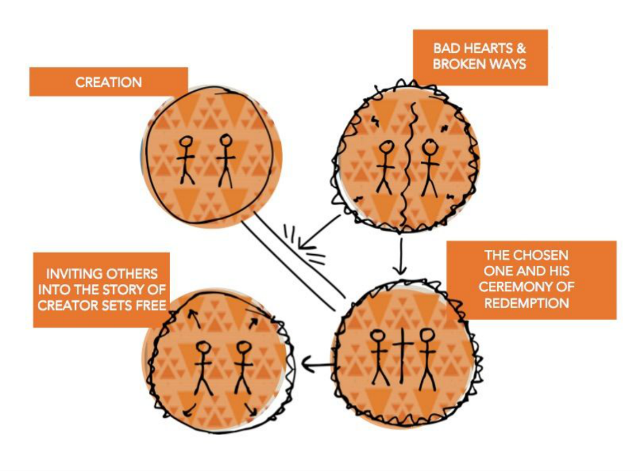
Gospel Presentation
The First World: Creation
Creator formed a beautiful and harmonious world and creation. All people were made in His image and created for good. He made us with purpose, dignity, and beauty. We were designed to live in peace and harmony with ourselves and one another, with Creation and with Creator.

The Second World: Bad Hearts & Broken Ways
But if you look around, that is not the world we are living in today. Creation is broken, and death and discord bind people. Turn on the news and you are bombarded with racism, violence, stereotyping, fear, and destruction.
There’s a lot of brokenness in this world, and that is experienced in Native communities in huge ways, both now and in the past. That includes a lot of injustice and lies committed in the name of Jesus against Native peoples. Bad hearted people with broken ways distorted what this story looked like. It grieves Creator’s heart.
Our world is clearly divided and hurting, and in need of real hope. And the brokenness is not just out there, it’s also within us. The broken things done to us by people with bad hearts often leave scars. Our hearts become scarred, and we become misguided as we too follow broken ways. Accuser, the evil spirit enemy of Creator, works to twist the hearts of all peoples. All of us need new hearts and new ways.

The Third World: The Chosen One and His Ceremony of Redemption
Jesus came to save us from our bad hearts and broken ways and to free us from the road of death. That’s what Jesus’ name means: Creator Sets Free. Maker of All Things sent Creator Sets Free to sacrifice himself in this Cross Ceremony and to be raised from death, redeeming us all.
By performing this ceremony he took back the power from the evil Accuser. He broke the bonds the Evil One had put on us and he opened the way for us to walk the good road. To receive this gift we must simply trust in the Creator’s Son and follow him.
All are invited to ponder this claim. It is a Good Story of how much Maker of All Things loves us. It is not the story of a god of conquerors or a form of violence against Native people or culture.
This is the Son of the Creator who came to our land of tears, war and brokenness to save us and give us a way out. He came to heal our bodies and our hearts and to make us fully alive because he loves us so much and wishes to see no one suffer death and separation. And he calls us to strive to do his will in his Sacred Family (the Church).
This good news, this invitation to walk on the Jesus Way, is for all peoples and languages and cultures. Creator made people in His image with the gift of creating culture and language and tradition. He isn’t separate from those things; he was born to a specific people, time, and culture. Creator speaks all languages and He is revealing His true self in the ways of all peoples.

The Fourth World: Inviting Others into the Story of Creator Sets Free
Experiencing this healing story together, we await Creator Sets Free’s return as we participate in telling this Good Story of Healing and inviting others to join us on the road that leads to life.
This is the Jesus Way. By giving our lives to Jesus, we get to follow Him on the Jesus Way and receive restoration from Him. We are also sent and empowered to be a source of healing for others: our friends, family, communities, and world.

Invitation to Respond
Where do you see yourself in the Story?
Healing: Where is a place that Creator Sets Free can bring healing to a bad heart or broken way in your life? Would you be willing to ask him to do that for you now?
Conversion: Creator Sets Free is inviting you to follow him in the Jesus Way. Would you say yes to following him?
Outreach: Others around you need the healing and hope offered on the Jesus Way. Would you say yes to inviting them to his Good Story?

