“What Should I Call Them?”
This is one of the most frequent questions we hear from folks intimidated to interact with Native people. Confusion over terminology is not just a matter of political correctness, and it’s not an accident. Our treatment of Native peoples is an unpleasant reality that we would rather not have on our national resume. Thus, many Americans have never learned about the tribes who do or used to live in their area, or met real Native people. So it’s not your fault if you don’t know what to call them, but it is time to start learning.
No Really—What Should I Call Them?
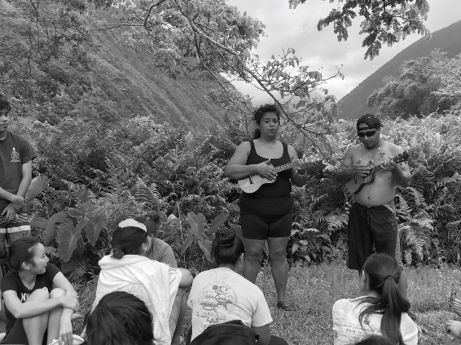
There are 566 Native tribes/nations recognized by the US federal government The best term when referring to a Native person is to use her/his nation: “My Ojibwe friend,” “He’s Choctaw of Oklahoma,” “I think she’s a Spokane Native American,” etc. Find out what your Native friend calls his/her tribe, since many tribes are referred to both in their tribe’s language and in a colonial language (take Anishinaabe, the Native word, for Ojibwe, the French word—tribes in the Minnesota area). If you are referring to a mixed-nation group, “Native people,” “Indigenous people,” or “First peoples,” are good terms to use (“people” is general, “peoples” denotes multiple tribes). “American Indian” is an historic term used in many legal documents, and many Native people still refer to themselves casually as “Indians” (or “NDN” while texting!), but we recommend that if you’re new to the community, especially when you are first meeting someone, “Native” is a better term.
“Native Hawaiian” (once used to refer to Hawaiian Nationals before the illegal overthrow of the Hawaiian Kingdom in 1893) is not a term for everyone from Hawai’i, but refers to the indigenous Polynesian inhabitants of that land also known as Kanaka Maoli (through bloodline). “Pacific Islanders” or “Pasifika” are part of a larger group including other Polynesian, Micronesian and Melanesian Islander groups (but not, for example, including island nations like Indonesia or Japan). Other peoples in Hawai’i, such as Filipino and Japanese immigrants, may have been there for generations, but would be referred to by the community in Hawai’i as “locals.” Like Hawaiians, Natives in Alaska would also prefer “Native Alaskan” to “American Indian,” but as you learn more you should refer to your friend’s tribe or village.
What About ‘Native American’?
“Native American” is a misnomer in that there was no America for anyone to be native to when colonists first arrived on this continent. Canada gets it better with “First Nations.” However, “Native American” is generally a socially-acceptable way to refer to folks who possess a dual national citizenship and sense of belonging—to both a tribal nation and to the United States. Such folks may identify primarily with their tribal nation, or may have a bi-cultural sense of identity.
Are There Native People Where I Live?
Most Americans have heard of (or seen portrayed on TV/movies) some of the big tribes from the Plains and Southwest regions: Sioux (Lakota), Navajo (Dine), Apache. It is true that some regions of the US have higher Native population density if those regions were not as easily colonized, but all major US cities have Native populations, and all soils now “American” have a Native history that may live on in descendants who may not look stereotypically Native. 78% of Natives do not live on their reservation. Many move across the state or country for work or school, just like the rest of us.
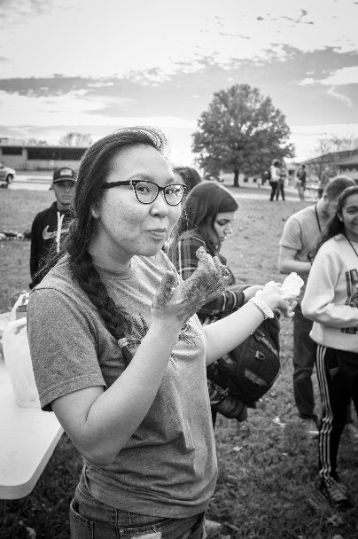
Why Aren’t There Many Native People Where I Live?
You probably did not learn too much about America’s Native genocide in public school, but scholars agree that what happened to Native peoples falls under the United Nations’ definition of genocide. Here is a very quick summary of what happened, and you can read the longer “What Should I Call Them?” article at the Start Something Native website. Check out separate articles there for important notes on and history of Hawaii and Alaska.
- 1492 - 1800s Contact and Disease: Colonists brought European diseases, to which Native people had little curative knowledge or immunity. Disease (or disease aided by vulnerability due to famine, war, dislocation or forced labor) may have wiped out ninety percent of the population. In acts of germ warfare, colonizers intentionally used blankets to spread disease.
- 1492 - 1900 Forced Labor: Slavery was legal in all thirteen original British colonies and Native slaves were often sent to the West Indies, where their lack of geographical knowledge made it harder for them to escape. Trafficking flourished in many places where slavery was technically illegal. Anywhere from 150,000 to 340,000 Native people were enslaved.
- 1540 - 1924 Warfare: Roughly 90 distinct wars waged across what would become North America between colonists (British, French and Spanish) and Native nations with countless massacres enacted by colonists (at least 50 distinct massacres where between 100-1000 Natives were slaughtered).
- 1780 - Onward Treaty Violations & Removal to Reservations: The US formed international treaties with Native nations stipulating borders which it then almost immediately broke to seize more land as Americans expanded westward. Reservations were essentially set up as internment camps for Native people removed from their homelands. The Trail of Tears and the reservations set up in Oklahoma are the most famous instance of this, but there were many.
- 1940 - 1960s Termination: This was the official federal policy, terminating the nation-to-nation relationship between the US and over 100 tribes, essentially saying that the US would not acknowledge these tribes as existing legally. Among many others, all tribes in California, Florida, Texas, and New York were “terminated” during this period.
- Late 1800s - 1970s Boarding Schools: The government pressured (in many cases kidnaped) Native children from their homes and sent them to boarding schools in order to assimilate Native people into Western culture. Children were stripped of their culture and abused in every other fashion. These schools were mostly run by missionaries. Many Native elders alive today are boarding school survivors.

