The Spiritual Significance of Seeing the Native Students on Your Campus
Then the LORD said to Cain, “Where is Abel your brother?” And he said, “I do not know. Am I my brother’s keeper?” He said, “What have you done? The voice of your brother’s blood is crying to Me from the ground. “Now you are cursed from the ground, which has opened its mouth to receive your brother’s blood from your hand. “When you cultivate the ground, it will no longer yield its strength to you; you will be a vagrant and a wanderer on the earth.” (Genesis 4:9-12)
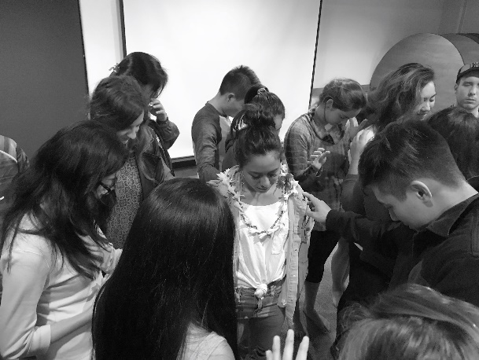
Genesis makes it clear that in places where innocent blood has been shed—even though it may be in the past—the voice of that blood cries out to God for justice, and a curse falls on the oppressor and even on the land because of violence.
The genocide against Native peoples (and against African slaves) are the primordial murders still crying out from the soil of this continent. Where are the Native people? we might hear the Lord saying. And like Cain, the American church has often responded, I do not know. Am I my brother’s keeper? We have existed in a state of denial, and by ignoring God’s obvious question, we see the consequences of a ravaged land and a grossly inequitable social structure firmly established by the powers and principalities of class, race, and ethnicity. We have ignored the host people to whom God first gave the land. We have ignored the wisdom of those who have been stewarding this place for millennia. We have ignored our forefathers’ and foremothers’ complicity in their near-extinction. But God’s implied, definitive YES to the question “Am I my brother’s keeper?” calls us today to hear the cry of our Native siblings’ ancestors’ spilled blood, and determine to be a brother or sister.
As with any historic injustice, Satan opposes our attempts to bring injustice against Native people to light. Satan has effectively kept Native people and their political issues hidden from the eyes of America and the church, using fear, shame, denial, and a multitude of lies to create misunderstanding around Native peoples. As we choose to align with the way Creator sees and values Native students, we are not only “reaching an unreached corner of campus,” but we are joining with the God who brings dark, hidden things to light (Job 12:22).
Many students who identify as Native or are tribally enrolled may not “look Native” (as we are used to seeing Natives portrayed on TV). Acknowledging their identity and value as Native is part of fighting against the “invisibility” they and their ancestors have been dealing with their whole lives.
We are well aware in Native InterVarsity that in many regions, reaching Native students won’t happen quickly and probably won’t rapidly grow your chapter, but we are also strongly convicted that as we see and honor the first people of our land, we will see the Spirit move in power. If Native students are “statistically irrelevant” in your region, consider the fact that this is merely due to sin. As we find ways to honor the Native people of our region -- even off campus -- we may experience God’s blessing in unexpected ways.

